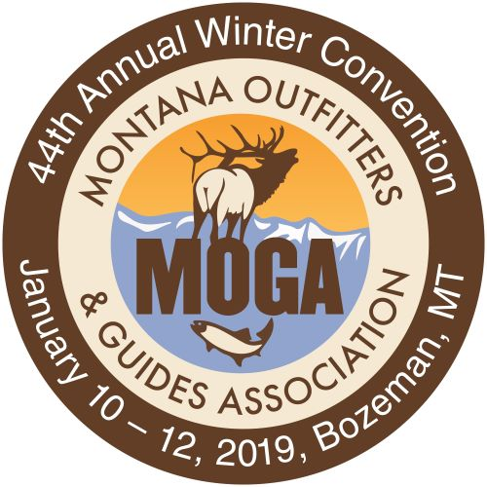

Representing the Interests of the Montana Outfitting Industry Since 1949

44th MOGA WINTER CONVENTION
Conservation Tourism Service

Best Western Gran Tree Inn
Bozeman, Montana
January 10 – 12, 2018

Convention Agenda

Thursday January 10th
1:00 – 4:00 pm MOGA Board of Directors Meeting MADISON
3:00 –6:00 pm Registration Desk Open FOYER
4:00 –6:00 pm Tradeshow Setup ATRIUM/FOYER

Friday January 11th
7:30 am Registration Desk Open FOYER
7:15 – 8:00 am Tradeshow Open – Coffee ATRIUM/FOYER
8:00 – 8:30 am General Membership Meeting TAMARACK/ASPEN President’s Welcome – Wagner Harmon
8:30 – 9:30 am AIS in Montana and the strategy to address it TAMARACK/ASPEN
Thomas Woolf, AIS Bureau Chief

9:30 – 10:00 am Break/Tradeshow ATRIUM/FOYER
Coffee

10:00 – 10:45 Understanding Montana Stream TAMARACK/ASPEN
Access Laws
Bill Schenk, FWP Legal Council

10:45 – 11:30 am Successful Outfitter Strategies TAMARAC/ASPEN
- Managing Client License Applications to Maximize Draw Success Karla Smith (20 min)
- New Licensee Lookup System

11:30 – 12:00 noon Break/Tradeshow ATRIUM/FOYER

12:00 – 1:00 pm Lunch and Guest Speaker HALITE/CLARK/LEWIS
Martha Williams – FWP Director

1:15 – 2:00 pm Bear Safety in Bear Country TAMARACK/ASPEN
Gary Moses, Counter Assault

2:00 – 2:45 pm MOGA on the MOVE TAMARACK/ASPEN
Wagner Harmon, President
Mac Minard, Executive Director

2:45 – 3:15 pm Break/Tradeshow- Coffee and Cookies ATRIUM/FOYER

3:15 – 4:15 pm Board of Outfitters Updates/FAQ TAMARACK/ASPEN
Rob Arnaud, Todd Earp, Steve Gallus, John Way, Pat Tabor
    - 5 TOP MBO violations and steps necessary to avoid them
    - OA Dos and Don’ts
    - MBO Year-end reporting

4:30 – 5:30 pm Millennials in the Workplace and as Clients TAMARACK/ASPEN
Pat Tabor

5:30 – 6:30 pm Happy Hour in Tradeshow Venue ATRIUM/FOYER
Sponsored by SITKA

6:30 pm MOGA Awards Dinner BALLROOM
Jean Johnson, Guest of Honor

Saturday January 12th
7:00 - 8:00 am Prayer Breakfast MADISON
Pastor Brett LaShell will lead a session of fellowship and thanksgiving

8:00 am Registration Desk Open FOYER

8:30 – 10:30 am MOGA Members Meeting/Breakouts TAMARACK/ASPEN

Breakout Topics:
- Legislation. General discussion on legislative priorities and review of critical races.
- HADF and Your MOGA Membership
- Issues Important to Association Members

10:30 – 11:30 pm Spreading the News to Non-Hunters TAMARACK/ASPEN
Diana Rupp

12:00 – 1:30 pm Lunch HALITE/CLARK/LEWIS
Michael Sabbath - Defending and Advancing Hunting in a
Post-Modern World and the Rural – Urban Divide

1:45 – 3:45 pm Concurrent Conservation Sessions

- Madison River Fisheries Management TAMARACK/ASPEN
This will be a facilitated discussion open to Convention Registrants (MOGA members or not). Bring in the experts in the field from Montana and other states. Explain the Negotiated Rule Making process, identify and examine problem statements and issues and catalog Outfitter opinions. It is hoped that this session result will inform the Outfitter position on management options considered during the Madison River Negotiated Rule Making Process.

- Mountain Lion Monitoring and Management Strategy MADISON
This session is open to Convention Registrants and will divided into two discussions:
- Mountain Lion Monitoring and Management Strategy proposal review – Jay Kolby, FWP
- Management strategies, legislation and allocative recommendations – Facilitated Outfitter discussion

4:00 - 4:15 pm Meeting Close TAMARACK/ASPEN
Wagner Harmon - MOGA President

4:30 - 6:00 pm Big Hearts under the Big Sky ATRIUM
Meet and Greet Check In, Silent Auction, Happy Hour

6:00 – 10:00 pm Big Hearts under the Big Sky BALLROOM
Banquet and Auction

