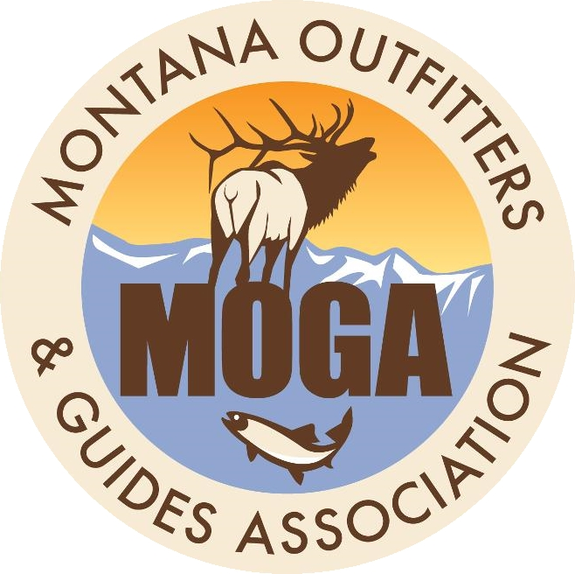

INHERENT RISK TEMPLATE (Waiver & Release)
ORDER FORM

Part 1 - Contact Information

Legal Name of Company: ______________________________________________________________________
Business Type of Entity (LLC, Inc, LLP): _____________________ Date of Request: ________________________
Owners Name (Authorizing Agent): ______________________________________________________________
Primary Phone: ___________________________ E-mail: ___________________________________________
Address: ____________________________________________________________________________________
Business Address: __________________________ City: __________________ State: _______ Zip: ___________

Part 2 - Identification of Service(s)
Primary Service(s): □ Hunting □ Fishing □ Horseback □ Floating □ Vehicle Shuttle
Note: Each primary service requires a separate Waiver and Release document. Mark each that applies to your business(s).

Ancillary Services: □ Camping □ Food Service □ Non-carrier shuttle □ Floating
□ Horseback (with Hunting as Primary) □ Horseback (with Fishing as Primary)
Note: Any of these services may be joined to any of the primary services identified above.

Part 3 - Payment Information

MOGA Member: Yes _____ No ______

MOGA Member Price per Template: 1st $395.00 ______; Subsequent Templates $295.00 ______

Part 3 - Payment Information (continued)

Payment by Check: Check # __________ Amount $___________
OR
Payment by Credit Card: Amount $___________
Credit card: □ Visa □ MC □ Discover (we do not accept American Express)
Name as it appears on card: ___________________________________________________________
Billing Street Address: ________________________________________________________________
City: ___________________________________ State: __________ Zip: ________________
Card Number: ______________________________________________ Exp. Date: _______________
CVV code on back of card: __________

Part 4 - Required Acknowledgments (must be read and signed)

REQUESTOR ACKNOWLGEMENT AND ACCEPTANCE OF TERMS:
By signing below, I acknowledge that I have been informed by the Montana Outfitters and Guides Association (MOGA) that by purchasing this Participant Release of Liability, Waiver of Claims, Assumption of Risks and Indemnity Agreement template, I, in no way, have received any service or documents that would constitute legal advice. Furthermore, I understand that I have an obligation to review the template for accuracy and completeness, and my receipt of the document should be deemed as receipt of a “draft.” Finally, I acknowledge that MOGA has suggested that the template, taken in conjunction with simple review of the compatibility of the draft waiver/release agreement, with all other legal matters and correspondence of my company by my attorney is highly recommended. I also understand that the materials I will receive are for my use only and I agree to not forward the product to others.

Signed: ___________________________________________________
Printed Name: _____________________________________________
Title: _____________________________________________________
Date: _____________________________________________________

Part 5 - Return Form and Payment to MOGA Office
Mail to: MOGA OR Email: mogaoffice@mt.net
2021 11th Avenue, Ste. 12
Helena, MT 59601

Instructions for Completing Inherent Risk Order Form
This is intended to be a simple process that will take only minutes to complete. Please refer to these instructions if you have questions on how to complete your order form. If you are still unclear, please call the office at (406) 449-3578 between 9:00 am and 4:00 pm Monday – Friday. If an emergency call Mac’s cell phone at (406) 439-2059.

Part 1 - Contact Information
Under Legal Name of Company include the type of company you operate. The options include:
- Limited Liability Companies (LLC)
- Sub Chapters S or C (Inc.)
- Limited Liability Partnerships (LLP)
- Sole Proprietorships (no initials after company name)

Part 2 - Identification of Service(s)
You need to determine the number of Waiver templates that will be necessary to construct as it is common for a diversified business to need more than one waiver. For instance, you may offer summer pack trips, float fishing and hunting in the fall. In this case, you will need three separate waivers. We need to avoid creating one massive waiver that attempts to cover all service for the year and ask people to sign them if they include services they are not involved with. Therefore, we have set the Order Form up to have Primary (Hunting, Fishing, Horseback, and Floating) and Ancillary (Camping, Food Service, Non-carrier shuttle, and Floating) options.
- Primary Service(s)
  - Hunting (describe services and/or activity as hunting)
  - Fishing (describe services and/or activity as fishing)
  - Horseback (describe services and/or activity as horseback riding, trail rides or pack trips)
  - Floating (describes services and/or activity as boating, floating or other water-related activity)

- Ancillary services done in conjunction with primary service (Can be included as part of the standalone waiver for hunting, fishing, horseback or floating)
  - For Horseback Hunts: Use hunting (primary) plus horseback (ancillary)
  - For Pack Trips: Use horseback (primary) plus camp (and fishing if provided) as ancillary
  - For Multi-Night Fishing: Use fishing plus camping
  - Add these paragraphs if they indicated that they provide these services as well:
    - Camping
    - Food service
    - Non-carrier shuttle

Part 3 - Payment Information
Our goal is to provide MOGA members a deep discount on the process of getting a useful Waiver and Release documents(s) in place by providing a starting template for you to review and discuss with your attorney if you so desire. We can receive a check, cash or credit card payments.

Part 4 - Required Acknowledgments (must be read and signed)
MOGA is NOT providing legal advice; we are simply offering you a DRAFT as a starting point for your Release and Liability Waivers development. You will need to review them and taper them to your business. You may elect to involve your attorney as we suggest.

*** You must read and sign Part 4 and return it to the office with your payment
before we will offer you the draft language.

